Quantifying our World into Data

**Pre-requisites:** Make sure to upload the previous week’s PDF in your GitHub, under the deliverables folder. Upload your file using a proper naming convention: “Your_ID_Name_DataLabName_File_Number”. For example the file name should look like: “233594_StigterMees_Week4DataLab1_1”. Insert the GitHub link in your learning log for this week with a brief description. Only files on GitHub and BrightSpace (Teams / Outlook) are considered for grading. For details on staff availability, see the [Creative Brief](https://adsai.buas.nl/Year1/BlockA/).

Goals,

* Quantifying real—world phenomena and objects into data
* Use Power BI

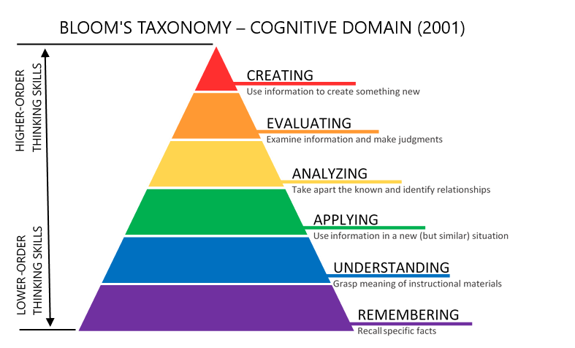

How to write a Research question in 2024

What is a research question? > A question that a study or research project, through its thesis statement, aims to answer (A thesis statement comprises one or two declarative sentences that summarize the main point of a paper or a piece of writing such as an essay).

The question often addresses an issue or a problem, which, through analysis and interpretation of data, is answered in the study’s conclusion. These questions are dynamic; this means researchers can change or refine the research question ad they review related literature and develop a framework for the study. (larger studies often use more than one research question)

[Types of research questions](https://research.com/research/how-to-write-a-research-question#what)

* **Quantitative research questions**

[ These questions are precise, include the population to be studied, dependent and independent variables, and the research design to be used.

[ Establish a ling between the research question and the research design. Moreover, these questions are not answerable with “yes” or “no” responses. As a result, quantitative research questions don’t use words such as “is,” “are,” “do,” or “does,”

[ The usually seek to understand particular social, familial, or educational experiences or processes that occur in a particular context and/or location.

[ They can be further categorized into three types: descriptive, comparative, and relationship

* *Descriptive research questions* aim to measure the responses of a study’s population to one or more variables or describe variables that the research will measure. These questions typically begin with “what”.
* *Comparative research questions* aim to discover the differences between two or more groups for an outcome variable. These questions can be casual, as well. For instance, the researcher may compare a group where a certain variable is involved and another group where the variable is not present.
* *Relationship research questions* seek to explore and define trends and interactions between two or more variables. This research question design often includes both dependent and independent variables and use words such as “association” or “trends”
* Qualitative research question

[ These questions may concern broad areas of research or more specific areas of study. Similar to quantitative research questions, qualitative research questions are linked to research design. Unlike their quantitative counterparts, though, qualitative research questions are usually adaptable, non-directional, and more flexible.

[ Studies using these questions generally aim to “discover,” “explain,” or “explore.”

* Contextual research questions seek to describe the nature of what already exists.
* Descriptive research questions attempt to describe a phenomenon
* Emancipatory research questions aim to produce knowledge that allows for engagement in social action, especially for the benefit of disadvantaged people.
* Evaluative research questions assess the effectiveness of existing methods or paradigms.
* Explanatory research questions seek to expound on a phenomenon or examine reasons for and associations between what exists.
* generative research questions aim to provide new ideas for development of theories and actions.
* Ideological research questions are used in research that aims to advance specific ideologies of a position.